Is There a Relationship Between Height and Weight?
Name
Institution of Affiliation
Date
Is There a Relationship Between Height and Weight?
Summary
This study aimed to establish the relationship between height and weight. Data from the Australian and New Zealand Dialysis and Transplant Industry was analyzed, focusing on the height and weight variables. Various analyses were done using R Studio, including the scatter plot and the Abline linear model showed a linear relationship between height and weight with a correlation coefficient of 0.70. It was concluded that height and weight are related.
Introduction
There is a long-standing notion that height and weight are related. The two variables are used in the calculation of body mass index (BMI). However, this relationship is not universally applicable. Studies that have sought to establish the relationship between height have shown varying results. For example, a study from Diverse Populations Collaborative Group (2005) showed that weight is not universally dependent on height. Thus the use of BMI cannot justify the relationship between these two variables. Regardless, there is still the idea that taller people weigh more than shorter people, implying that height influences the weight of an individual. Based on this assumption, this study investigates whether height and weight are related by analyzing data from the Australian and New Zealand Dialysis and Transplant Industry. The data consists of individuals of different heights and weights to analyze the relationship between the two variables. The R studio is used for data analysis to visualize the correlations before making valid conclusions.
Data Analysis
The data from Australian and New Zealand Dialysis and Transplant Industry was imported to the R studio. The first step was to summarize the relevant variables, i.e., height and weight. Summaries were done separately. It was observed that there were some missing data values, and this was corrected using the na.omit function. A histogram plot for each variable was then done to visualize their general distribution in the sample data. To establish if there was a linear trend between the variables, a scatterplot was plotted and an abline for a linear model; height was the x variable while weight was the y variable. Correlation analysis using Pearson’s correlation was then conducted to establish the association between the two variables. The following data R codes were used for the data analysis:
Head(ANZDATA)
Summary(ANZDATA)
Head(ANZDATA)
na.omit(ANZDATA$height)
na.omit(ANZDATA$weight)
summary(ANZDATA$height)
summary(ANZDATA$weight)
hist(ANZDATA$height, main="Distribution of Height in the Data", col="red")
hist(ANZDATA$weight, main="Distribution of Weight in the Data", col="green")
plot(ANZDATA$height, ANZDATA$weight, main="Relationship between Height and Weight”, xlab="Height”, ylab="Weight")
abline(lm(ANZDATA$weight ANZDATA$height), col="red")
cor.test(ANZDATA$height, ANZDATA$weight, use = “complete.obs”, method= “pearson”)
Results
After analyzing the 255 individuals from the data, there was an affirmation that height and weight have a close relationship. The summary statistics for the height variable are shown in table 1, while those of weight are shown in table 2. The mean height was 167.8, while that of weight was 75.16.
Table 1: Summary Statistics for the Height Variable
Table 2:Summary Statistics for the Weight Variable
A plot of the histograms for both height and weight indicated that the two variables’ data are normally distributed, with most of the data values located at the center. This makes the mean and median appropriate measures for describing the distribution of the data. The histograms are illustrated in Figures 1 and 2.
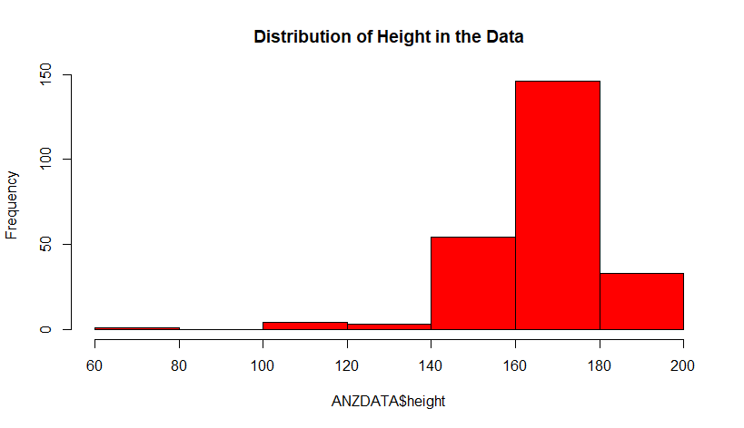
Figure 1: Histogram for the weight variable
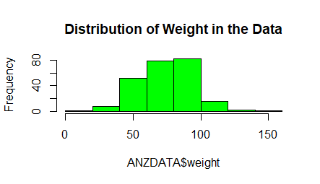
Figure 2:Histogram for the weight variable
The scatterplot showed whether the association between height and weight is approximately linear. It revealed that weight tends to increase as a function of height. This is shown in figure 3 below, while figure4 illustrates the linear trend of the data. There is a substantial spread in this data but no discernible curvature. Therefore, it is appropriate to summarize the association in terms of the correlation coefficient.
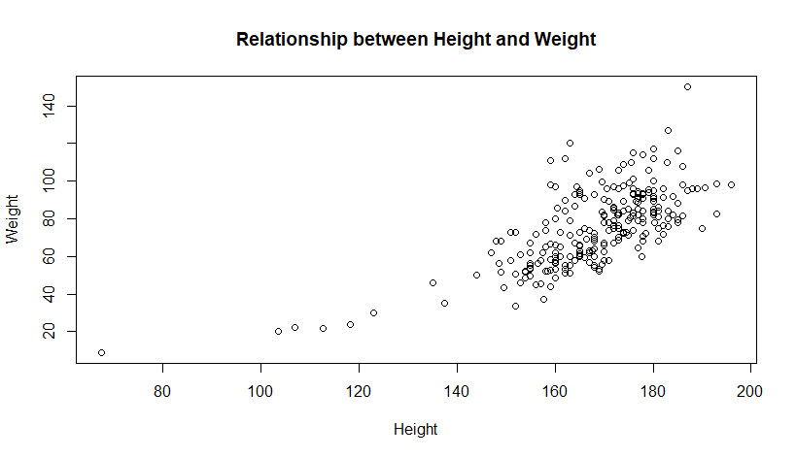
Figure 3:Scatter plot for the association between height and weight
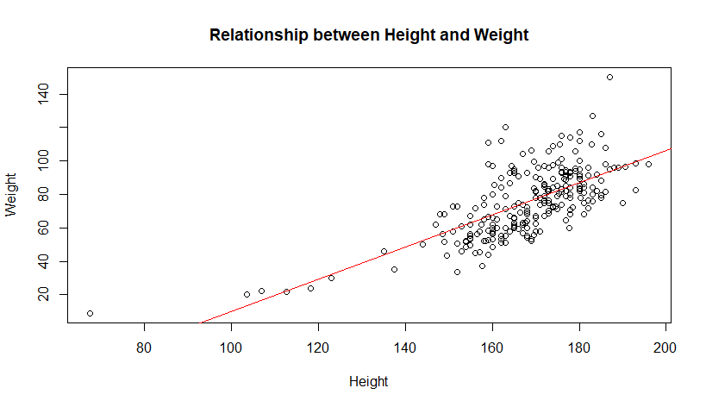
Figure 4:Abline plot for the linear model of the association between height and weight
There was some scatter in the data, and therefore the correlation coefficient had to be less than one. The computation of the correlation coefficient yielded 0.70, which is a reasonably modest correlation. The significant level used in the analysis was 0.05, and the 95 percent confidence interval yielded a correlation coefficient between 0.63 and 0.76. A correlation coefficient of 0.70 indicates that the two variables are positively correlated; when height increases, weight also increases. However, the correlation is not perfect as it less than one; therefore, they are values that do not reflect this correlation.
Conclusion
Based on the study results, it is apparent that height and weight have a close relationship. They are closely related to weight, majorly depending on the height of the individual. Taller people weigh more than their shorter counterparts (Gorber et al., 2007). Therefore, height can be used as the basis for predicting the weight of an individual.

References
Diverse Populations Collaborative Group. (2005). Weight‐height relationships and body mass index: some observations from the Diverse Populations Collaboration. American journal of physical anthropology, 128(1), 220-229.
Gorber, S. C., Tremblay, M., Moher, D., & Gorber, B. (2007). A comparison of direct vs. self‐report measures for assessing height, weight and body mass index: a systematic review. Obesity reviews, 8(4), 307-326.

